Core Java
*************************
1. Why String is Immutable?
Strings in Java are specified as immutable because strings with the same content share storage in a single pool to minimize creating a copy of the same value. That is to say, once a String is generated, its content cannot be changed and hence changing content will lead to the creation of a new String.
Eg: String s1 = new String (“hello”);
String s2 = “hello”;
String s3 = new String (“hello”);
String s4 = “hello”;

System.out.println(s1 == s2); // Output: false //==checks for object reference
System.out.println(s1 == s3); // Output: false
System.out.println(s2 == s4); // Output: true

System.out.println(s1.equals(s2)); // Output: true // .equals checks for the content
System.out.println(s1.equals(s3)); // Output: true
System.out.println(s2.equals(s4)); // Output: true

s1 & s3 will store “hello” value in the heap memory whereas s2 and s4 will store it in string constant pool will share the same memory object.

String s1= new String("vazeer").intern();
String s2= new String("vazeer").intern();
System.out.println(s1 == s2); //true. Both will be in SCP

2. Why wait(), Notify() and NotifyAll() methods are in Object class why not in Thread class?
As every object in java has only one lock(monitor) and wait (), notify (),notifyAll() are used for monitor sharing that’s why they are part of Object class rather than Thread class.
If wait() and notify() were on the Thread instead then each thread would have to know the status of every other thread and there is no way to know thread1 that thread2 was waiting for any resource to access. Hence, notify, wait, notifyAll methods are defined in object class in Java.

3. How do you achieve object as polymorphic nature in java not methods?
Static polymorphism in Java is achieved by method overloading (compile-time polymorphism). Dynamic polymorphism in Java is achieved by method overriding (run-time polymorphism).

4. Explain about interthread communication methods?
Inter-thread communication in Java is a mechanism in which a thread is paused running in its critical section and another thread is allowed to enter (or lock) in the same critical section to be executed.

5. Difference b/w synchronized method vs synchronized block?
Synchronized block is used to prevent multiple threads from executing a portion of a code in a method at the same point in time. On the other hand, synchronized method will prevent multiple threads from executing the entire method at the same point in time.

6. About Transient, native, Static, intern keywords?
transient is a variable modifier used in serialization. At the time of serialization, if we don’t want to save value of a particular variable in a file, then we use transient keyword. When JVM comes across transient keyword, it ignores original value of the variable and save default value of that variable data type.
private transient <member variable>;
transient int k = 30; // k=0 here because of transient

The native keyword in Java is applied to a method to indicate that the method is implemented in native code using JNI (Java Native Interface). The native keyword is a modifier that is applicable only for methods, and we can’t apply it anywhere else.
Public native int square(int i);

The static keyword in Java is mainly used for memory management. The static keyword in Java is used to share the same variable or method of a given class. The users can apply static keywords with variables, methods, blocks, and nested classes.
Static int a = 10;

The method intern() creates an exact copy of a String object in the heap memory and stores it in the String constant pool. Note that, if another String with the same contents exists in the String constant pool, then a new object won't be created, and the new reference will point to the other String.
public String intern()

String str = new String("Welcome to JavaTpoint").intern(); // statement - 1
String str1 = new String("Welcome to JavaTpoint").intern(); // statement - 2
System.out.println(str1 == str); // prints true

7. explain about oops concept where you used in your project exactly?
  - Encapsulation (security purpose. we may tightly bind the variables by using private access modifier and access it using Getter and setter methods)
A real-life example of encapsulation can be seen in a car. In a car, various components such as the engine, transmission, brakes, and steering system work together to perform different functions. Each component encapsulates its functionality and hides its internal workings from other components.
  - Inheritance (acquiring one class properties by extending it)
  - Polymorphism
  - Abstraction

8. java 8 features Streams, Optional class, Lambda Expressions and functional Interfaces?
A stream Api in Java is a sequence of objects that supports various methods which can be. pipelined to produce the desired result.
Optional class was introduced in java8 which it can eliminate the nullpointer exception and give the normal flow of the program. A container object which may or may not contain a non-null value. If a value is present, isPresent() will return true and get() will return the value. Otherwise, if it’s not present then exception message will be printed.
A Lambda expression is a short block of code which takes in parameters and returns a value, which it doesn’t have any access modifier, return type and method name.
An Interface that contains exactly one abstract method is known as functional interface. It can have any number of default, static methods but can contain only one abstract method.

9. write small program by using functional interfaces?
@FunctionalInterface
interface Square {
int calculate(int x);
}

class Test {
public static void main(String args[])
{
int a = 5;
Square s = (int x) -> x * x;

int ans = s.calculate(a);
System.out.println(ans); //25
}
}

10. static method vs default method difference, where you used exactly in your project?
Static methods - They are declared using the static keyword and will be loaded into the memory along with the interface. You can access static methods using the interface name.
If your interface has a static method you need to call it using the name of the interface, just like static methods of a class.

interface MyInterface{
public void demo();
public static void display() {
System.out.println("This is a static method");
}
}
public class InterfaceExample{
public void demo() {
System.out.println("This is the implementation of the demo method");
}
public static void main(String args[]) {
InterfaceExample obj = new InterfaceExample();
obj.demo();
MyInterface.display();
}
}

Default Methods - Unlike other abstract methods these are the methods can have a default implementation. If you have default method in an interface, it is not mandatory to override (provide body) it in the classes that are already implementing this interface. Only interfaces can have default methods, not abstract classes.
In short, you can access the default methods of an interface using the objects of the implementing classes.

interface MyInterface{
public static int num = 100;
public default void display() {
System.out.println("display method of MyInterface");
}
}
public class InterfaceExample implements MyInterface{
public static void main(String args[]) {
InterfaceExample obj = new InterfaceExample();
obj.display();
}
}

11. Array List internally uses dynamic array, dynamic array internally uses array, so array is size fixed, then how Array List is not fixed size?
The size of an Array List is not fixed. We can increase or decrease its size as one adds or removes elements. We need to mention its size while creating an array. We can create an Array List instance without mentioning its size. By default, the array list size is 10.

12. HashMap internal implementation, hash table?
HashMap is a specific implementation of a Map that stores the key-value pairs directly within an array. In an internal HashMap, the key-value pairs are stored in an array called a hash table. The array is indexed using a hash function that converts each key into an index in the array.

HashMap Hash table
Works with Single thread Works with Multiple threads
Allows one null key No null key is allowed
Non-synchronized & not-thread safe synchronized & thread safe
No insertion order-maintained Insertion order maintained

13. thread safe in HashMap vs hash table?
HashMap is non-synchronized. It is not thread-safe and can't be shared between many threads without proper synchronization code whereas Hash table is synchronized. It is thread-safe and can be shared with many threads.

*********************
Spring framework
************************
1. functionality of IOC?
The IoC container is responsible to instantiate, configure and assemble the objects. The IoC container gets information from the XML file and works accordingly. The main tasks performed by IoC container are:
- to instantiate the application class
- to configure the object
- to assemble the dependencies between the objects

There are two types of IoC containers. They are:
1) Bean Factory -> instantiates the bean whenever it’s been asked by the clients
2) Application Context -> it’s built on the top of Bean factory.

2. spring bean life cycle?
Bean life cycle is managed by the spring container. Whenever we run the program, first of all, the spring container gets started. After that, the container creates the instance of a bean as per the request, and then dependencies are injected. And finally, the bean is destroyed when the spring container is closed. Therefore, if we want to execute some code on the bean instantiation and just after closing the spring container, then we can write that code inside the custom init() method and the destroy() method.

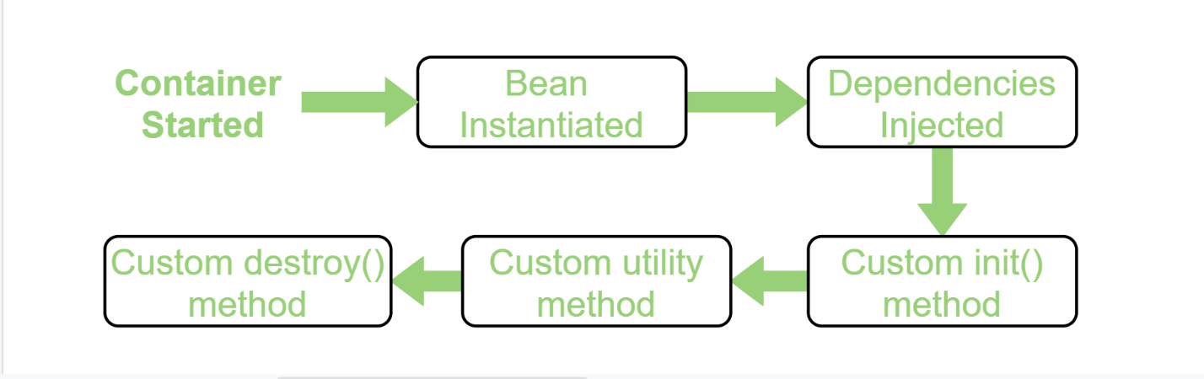

3. Auto wired, profile, component annotations in spring or what are the annotations used in your Spring based your project?
The @Autowired annotation in spring automatically injects the dependent beans into the associated references of a POJO class. This annotation will inject the dependent beans by matching the data-type (i.e. Works internally as Auto wiring by Type). The auto wiring functionality has four modes. These are ' no ', ' byName ', ' byType ' and ' constructor '. Another autowire mode autodetect has been deprecated.
Profiles in Spring Boot are a way to define different sets of configurations for your application depending on the environment it is being run in. For example, you might have one set of configurations for your development environment and another set of configurations for your production environment. You can set those profiles in application.properties by using spring.profiles.active = true
@Component is an annotation that allows Spring to detect our custom beans automatically. In other words, without having to write any explicit code, Spring will: Scan our application for classes annotated with @Component. Instantiate them and inject any specified dependencies into them.

4. Spring MVC life cycle?
refer diary

5. Spring AOP concepts? types of advices in AOP? which types of advices used in your project what is right situation demand to use AOP in your project?
Spring AOP is nothing but Aspect Oriented Programming which it has a cross-cutting concerns. Spring AOP will divide our primary logics and secondary logics by using cross-cutting concerns.
Spring AOP Concepts:
  - Aspect
  - Join point.
  - Advice
  - Pointcut
  - Introduction
  - Target object
  - AOP proxy
  - Weaving

Types of Advice:
1) before: Run advice before the method execution.
2) after: Run advice after the method execution, regardless of its outcome.
3) after-returning: Run advice after the method execution, only if the method completes successfully.
4) after-throwing: Run advice after the method execution, only if the method exits by throwing an exception.
5) around: Run advice before and after the advised method is invoked.

**************************
Spring Boot
**************************

1. Spring boot features? explain all features you used in your project?
  - Opinionated ‘starter' dependencies to simplify the build and application configuration.
  - Embedded server to avoid complexity in application deployment. Eg: Tomcat, jetty server is enabled by default.
  - Metrics, Health check, and externalized configuration
  - Automatic config for Spring functionality – whenever possible

2. what are the spring boot annotations you used in your project?
Spring Boot Annotations - javatpoint

3. spring boot command line runners?
CommandLineRunner is an interface used to indicate that a bean should run when it is contained within a Spring Application. A Spring Boot application can have multiple beans implementing CommandLineRunner. These can be ordered with @Order.

4. how the SpringbootApplication.run() works internally?
Spring Boot is very popular for its auto-configuration feature. This means it automatically configures our application based on the dependencies added during the project creation. As we don’t need to configure xml file, Spring internally does all the xml configuration which are provided by jar.

5. what is default dB and server in spring boot? how do you use our own dB or server?
Spring Boot gives you defaults on all things. For example, the default database is H2 . Consequently, when you want to use any other database, you must define the connection attributes in the application.properties file. Here, spring.jpa.hibernate.ddl-auto can be none, update, create, or create-drop.
Step 1 - Add dependency for your database connector to pom. xml. ...
Step 2 - Remove H2 Dependency from pom.xml. Or at least make its scope as test. ...
Step 3 - Setup your My SQL Database dependency
Step 4 - Setup your database connection. ...
Step 5 - Restart, and you're done!

With Spring Boot, the default embedded server is Tomcat. Other options available are Jetty and UnderTow. To use the embedded Jetty server instead of Tomcat, you need to exclude the spring-boot-starter-tomcat from spring-boot-starter-web and include the spring-boot-starter-jetty dependency. Also, you will need to exclude the default added spring-boot-starter-tomcat dependency.

6. application.properties vs YML file?
1) YML file
    - The extension for this type of file is. Yml.
    - It needs proper indentation otherwise we will encounter errors.
    - In YAML files, it is not necessary to repeat the same keys again and again.
    - It is more human readable than a properties file.
    - It can support multiple languages including Java, Python and Ruby.
    - We can include multiple spring profiles in a single YAML file.
2) application.properties
    - The extension for this type of file is .properties.
    - Indentation is not required in this file.
    - In properties files, the keys get repeated in each line.
    - It is a comparatively less human readable format.
    - It can support only a single programming language, i.e. Java.
    - For every environment of the spring profile, we need separate properties files

7. Spring Boot security?
Spring Security is a powerful and highly customizable authentication and access-control framework. It is the de-facto standard for securing Spring-based applications. Spring Security is a framework that focuses on providing both authentication and authorization to Java applications. Also, we can use OAuth2 for spring security.

****************************
RESTful and Microservices
****************************
1. Difference b/w RESTful and microservices?
REST APIs are a communication mechanism and is more of endpoints exposed to outer world and can be used with microservices as well, whereas Microservices represent an architectural style. REST APIs are commonly used within Microservices architectures. The choice between the two depends on the specific needs, requirements, and context of your application.

2. microservice architecture?
Microservices - also known as the microservice architecture - is an architectural style that structures an application as a collection of services that are:
- Independently deployable
- Loosely coupled

3. about API gate way?
An API gateway is a component of the app-delivery infrastructure that sits between clients and services and provides centralized handling of API communication between them.
An API gateway provides a single entry point for all API calls that come into an application, whether the app is hosted in an on-premises data center or on the cloud. It accepts requests that come in remotely and returns the requested data.

4. how do you communicate one service to another service?

1)REST API Calls
REST API calls are common methods of microservices to communicate. REST API calls enable microservices to share data and functionality, which allows microservices to work together seamlessly. To make a call, a microservice will need to know the endpoint of the called REST API and have the authentication to access this data or information. After the calling service sends the request, the called service will process it and provide a response. It’s a synchronous way of communication.

2)Message Brokers
Message brokers are another ideal solution for facilitating communication between microservices. It’s an asynchronous way of communication.

5. About Load balancing, Kafka?
Load balancers improve application performance by increasing response time and reducing network latency. They perform several critical tasks such as the following: Distribute the load evenly between servers to improve application performance. Redirect client requests to a geographically closer server to reduce latency.
Load balancing is a critical aspect of optimising performance and cost efficiency in Kafka clusters. It ensures that all nodes are utilised effectively and data is evenly distributed across the cluster.
Apache Kafka is an open-source distributed streaming system used for stream processing, real-time data pipelines, and data integration at scale
6
Microservices are deployed using VM or Containers. Containers are the preferred deployment route for microservices as containers are lighter, portable, and modular. The microservice code is packaged into a container image and deployed as a container service.

***************************
hibernate
******************************
1. hibernate vs JPA?
JPA is the Java specification and not the implementation. Hibernate is an implementation of JPA and uses common standards of Java Persistence API. It is the standard API that allows developers to perform database operations smoothly.
JPA | Hibernate
JPA is described in javax.persistence package. | Hibernate is described in org.hibernate package.
It describes the handling of relational data in Java applications. | Hibernate is an Object-Relational Mapping (ORM) tool that is used to save the Java objects in the relational database system.
It is not an implementation. It is only a Java specification. | Hibernate is an implementation of JPA. Hence, the common standard which is given by JPA is followed by Hibernate.
It is a standard API that permits to perform database operations. | It is used in mapping Java data types with SQL data types and database tables.
As an object-oriented query language, it uses Java Persistence Query Language (JPQL) to execute database operations. | As an object-oriented query language, it uses Hibernate Query Language (HQL) to execute database operations.
To interconnect with the entity manager factory for the persistence unit, it uses EntityManagerFactory interface. Thus, it gives an entity manager. | To create Session instances, it uses SessionFactory interface.
To make, read, and remove actions for instances of mapped entity classes, it uses EntityManager interface. This interface interconnects with the persistence condition. | To make, read, and remove actions for instances of mapped entity classes, it uses Session interface. It acts as a runtime interface between a Java application and Hibernate.
2. first level cache vs second level cache?

First Level Cache
Session object holds the first level cache data. It is enabled by default. The first level cache data will not be available to entire application. It’s available only for the current session. An application can use many session object.

Second Level Cache
SessionFactory object holds the second level cache data. The data stored in the second level cache will be available to entire application. But we need to enable it explicitly. Eg: EhCache

3. Inheritance mapping types and association mapping types?
Hibernate supports the three basic inheritance mapping strategies:
- table per class hierarchy.
- table per subclass.
- table per concrete class.
No. | Mapping type & Description
1 | Many-to-One Mapping many-to-one relationship using Hibernate
2 | One-to-One Mapping one-to-one relationship using Hibernate
3 | One-to-Many Mapping one-to-many relationship using Hibernate
4 | Many-to-Many Mapping many-to-many relationship using Hibernate

4. auto primary key generated classes?
If we want to automatically generate the primary key value, we can add the @GeneratedValue annotation. This can use four generation types: AUTO, IDENTITY, SEQUENCE and TABLE.
@GeneratedValue(Strategy = GenerationType.AUTO)

5. composite Key?
A composite key in SQL can be defined as a combination of multiple columns, and these columns are used to identify all the rows that are involved uniquely.

6. @GeneratedValue?
@GeneratedValue: This annotation is used to specify the primary key generation strategy to use. i.e Instructs database to generate a value for this field automatically. If the strategy is not specified by default AUTO will be used.
Generation Type Enum defines four strategies:
- Generation Type. TABLE,
- Generation Type. SEQUENCE,
- Generation Type. IDENTITY
- Generation Type. AUTO

@Id
@GeneratedValue(Strategy = GenerationType.AUTO)

7. cascading types?
Cascading in Hibernate refers to the automatic persistence of related entities. When a change is made to an entity, such as an update or deletion, the changes can be cascaded to related entities as well. Cascading can be configured using annotations, such as @OneToMany(cascade = CascadeType.ALL)
JPA Cascade Type
- ALL.
- PERSIST.
- MERGE.
- REMOVE.
- REFRESH.
- DETACH.

8. How you are managing from database down problem?
- Kill the queries that have been running for a long time.
- Quickly scale up your database if you have been seeing a consistent heavy usage.
- Check if the recent deployment is the culprit; if so, revert asap.
- Reboot the database will calm the storm and buy you some time.

11. different types of Queries like native query, derived Query?
Native queries are the most powerful and flexible way to implement your read operations. They enable you to use all features supported by your database, and Spring Data JPA handles almost all the required boilerplate code.
@Repository
public interface AuthorRepository extends CrudRepository<Author, Long>, PagingAndSortingRepository<Author, Long> {

@Query(value="select * from author a where a.last_name= ?1",
countQuery = "select count(id) from author a where a.last_name= ?1", nativeQuery = true)
Page<Author> getAuthorsByLastName(String lastname, Pageable page);
}

Derived Query:
Spring Data often gets praised for its derived query feature. As long as your method name starts with find…By, read…By, query…By, count…By, or get…By and follows the right pattern, Spring Data generates the required JPQL query.

Spring :
1.spring MVC flow
Check diary

2.dependency injection?
Dependency injection is basically providing the objects that an object needs (its dependencies) instead of having it construct them itself.
Classes often require references to other classes. For example, a Car class might need a reference to an Engine class. These required classes are called dependencies, and in this example the Car class is dependent on having an instance of the Engine class to run.

3. in ioc container, few people asked very basics?
The IoC container is responsible to instantiate, configure and assemble the objects. The IoC container gets information from the XML file and works accordingly. The main tasks performed by IoC container are:
- to instantiate the application class
- to configure the object
- to assemble the dependencies between the objects

There are two types of IoC containers. They are:
1) Bean Factory
2) Application Context

1. oops concepts(Anni detailed ga with examples)
  - Encapsulation (security purpose. we may tightly bind the variables by using private access modifier and access it using Getter and setter methods)
  - Inheritance (acquiring one class properties by extending it)
  - Polymorphism
  - Abstraction

2. jvm architecture
JVM (Java Virtual Machine) is an abstract machine. It is a specification that provides runtime environment in which java bytecode can be executed.
JVMs are available for many hardware and software platforms (i.e. JVM is platform dependent).
When we compile a .java file, jvm will convert it to .class files(contains byte-code) with the same class names present in .java file are generated by the Java compiler. This .class file goes into various steps when we run it. These steps together describe the whole JVM.
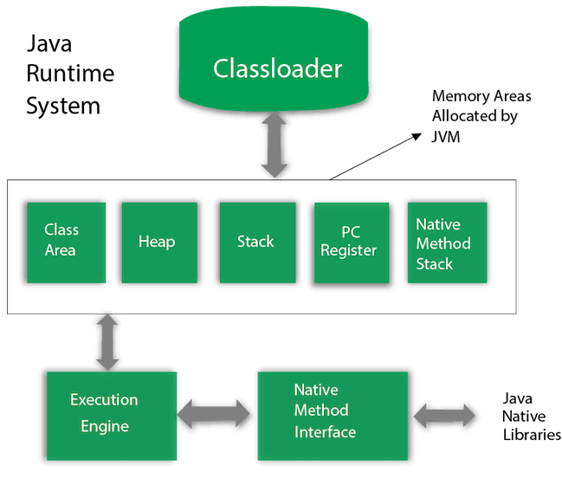

3. JVM, JDK, J2EE differences
JDK is an acronym for Java Development Kit. The Java Development Kit (JDK) is a software development environment which is used to develop Java applications. It physically exists. It contains JRE + development tools.
JRE is an acronym for Java Runtime Environment. It is also written as Java RTE. The Java Runtime Environment is a set of software tools and package of libraries which are used for developing Java applications. It is used to provide the runtime environment. It is the implementation of JVM. It physically exists. It contains a set of libraries + other files that JVM uses at runtime.
JVM (Java Virtual Machine) is an abstract machine. It is called a virtual machine because it doesn't physically exist. It is a specification that provides a runtime environment in which Java bytecode can be executed. It can also run those programs which are written in other languages and compiled to Java bytecode.
J2EE: stands for Java Enterprise Edition used to develop application on Server side (such as Servlet, EJB...)

4.constructor chaining?
Constructor chaining is the process of calling one constructor from another constructor with respect to current object. One of the main use of constructor chaining is to avoid duplicate codes while having multiple constructor (by means of constructor overloading) and make code more readable.
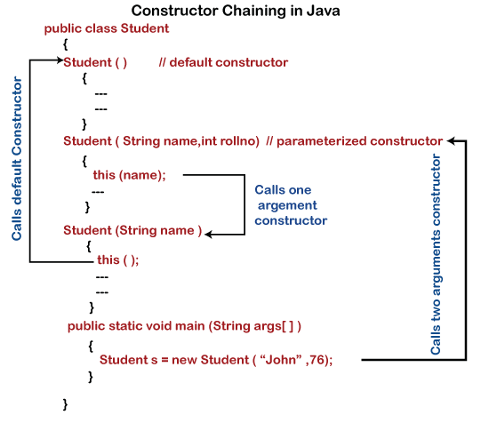
5.whether the constructor can be private or static. Different types of keywords are applicable.
Yes, we can declare a constructor as private. If we declare a constructor as private we are not able to create an object of a class(it will throw compile time error, because of private access modifier). We can use this private constructor in the Singleton Design Pattern.
One of the important property of java constructor is that it can not be static. We know static keyword belongs to a class rather than the object of a class. A constructor is called when an object of a class is created, so no use of the static constructor.

6.interface abstract differences
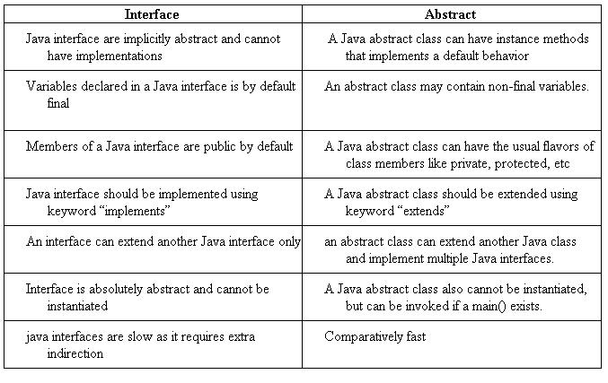
7.string buffer string builder differences.
Feature | String Buffer | String Builder
Synchronization | Synchronized | Not synchronized
Mutability | Mutable | Mutable
Usage | Suitable for multi-threaded environments | Suitable for single-threaded environments
Modifiability | Supports modification and appending | Supports modification and appending
Thread Safe | Thread safe | Not Thread Safe

8.string constant pool
A Java String constant Pool is a place in heap memory where all the strings defined in the program are stored. A separate place in a stack is there where the variable storing the string is stored. Whenever we create a new string object, JVM checks for the presence of the object in the String pool, If String is available in the pool, the same object reference is shared with the variable, else a new object is created.

9.thread
A thread, in the context of Java, is the path followed when executing a program. ... In Java, creating a thread is accomplished by implementing an interface and extending a class. Every Java thread is created and controlled by the java. lang. Thread class.
10.difference between sleep and wait

Wait() | Sleep()
Wait() method belongs to Object class. | Sleep() method belongs to Thread class.
Wait() method releases lock during Synchronization. | Sleep() method does not release the lock on object during Synchronization.
Wait() should be called only from Synchronized context. | There is no need to call sleep() from Synchronized context.
Wait() is not a static method. | Sleep() is a static method.
Wait() Has Three Overloaded Methods:  - wait()  - wait(long timeout)  - wait(long timeout, int nanos) | Sleep() Has Two Overloaded Methods:  - sleep(long millis)millis: milliseconds  - sleep(long millis,int nanos) nanos: Nanoseconds
public final void wait(long timeout)  synchronized(monitor)  {  monitor.wait();  } | public static void sleep(long millis) throws Interrupted_Execption  Thread.sleep();

11.difference between join and yield
property | yield() | join() | sleep()
purpose | If a thread wants to pass its execution to give chance to remaining threads of same priority then we should go for yield() | If a thread wants to wait until completing of some other thread then we should go for join() | If a thread does not want to perform any operation for a particular amount of time, then it goes for sleep()
Is it overloaded? | NO | YES | YES
Is it final? | NO | YES | NO
Is it throws? | NO | YES | YES
Is it native? | YES | NO | sleep(long ms)->native & sleep (long ms, int ns)-> non native
Is it static? | YES | NO | YES

12.multithreading
Multithreading in Java is a process of executing multiple threads simultaneously. A thread is a lightweight sub-process, the smallest unit of processing. Multiprocessing and multithreading, both are used to achieve multitasking. ... Java Multithreading is mostly used in games, animation, etc.
13.Types of Exception. How did you do exception handling in your project?

- Checked Exception:
The classes that directly inherit the Throwable class except RuntimeException and Error are known as checked exceptions. For example, IOException, SQLException, etc. Checked exceptions are checked at compile-time.
- Unchecked Exception:
The classes that inherit the RuntimeException are known as unchecked exceptions. For example, ArithmeticException, NullPointerException, ArrayIndexOutOfBoundsException, etc. Unchecked exceptions are not checked at compile-time, but they are checked at runtime.
- Error
Error is irrecoverable. Some example of errors are OutOfMemoryError, VirtualMachineError, AssertionError etc.
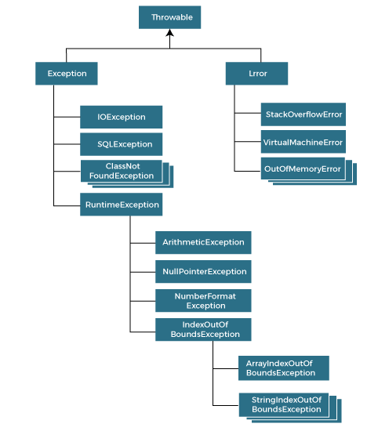

14.arraylist vs treemap
ArrayList is a dynamic, resizable array. It provides random access to its elements. Random access means that we can grab any element in constant time. ArrayList automatically expands as data is added. Unlike arrays, an ArrayList can hold data of multiple data types. Elements in the ArrayList are accessed via an integer index.
TreeMap is a map that is sorted according to the natural ordering of its keys. While a HashMap is more time-efficient, a TreeMap is more space-efficient.
15.arraylist vs linked list
1) ArrayList internally uses a dynamic array to store the elements. | LinkedList internally uses a doubly linked list to store the elements.
2) Manipulation with ArrayList is slow because it internally uses an array. If any element is removed from the array, all the other elements are shifted in memory. | Manipulation with LinkedList is faster than ArrayList because it uses a doubly linked list, so no bit shifting is required in memory.
3) An ArrayList class can act as a list only because it implements List only. | LinkedList class can act as a list and queue both because it implements List and Deque interfaces.
4) ArrayList is better for storing and accessing data. | LinkedList is better for manipulating data.

16.arraylist internal implementation
ArrayList is an dynamic array, as it will grow dynamically in nature. Initially, when we’re creating a new ArrayList with a no capacity, it will keep their size as 10.
ArrayList<Integer> list = new ArrayList<>();
When we’re inserting values into it up to 10 values, after 10th value in array we can’t able to fill as Arrays are static in name by default and it’ll throw Array Index Out of Bound exception, but in ArrayList we can able to create it as the size array grows when they’re exceeding the limit size that we have defined
New Capacity = old Capacity*(3/2) == New Capacity = old Capacity*1.5;

17.arraylist vs vector
Vector is legacy and was introduced in Java 1.0, while Array List is not legacy. After the release of the collection framework, both classes implement the same behavior due to extending the same classes and implementing the same interfaces. Vector is synchronized while ArrayList is not synchronized.

18.tree map vs linked hash map
Parameters | TreeMap | HashMap | LinkedHashMap
Performance | TreeMap offers O(logN) time complexity for basic operations. | HashMap provides O(1) time complexity for basic operations. | LinkedHashMap also provides O(1) time complexity for basic operations.
Null Keys | TreeMap does not permit null keys. | HashMap allows one null key. | LinkedHashMap permits one null key.
Null Values | TreeMap allows null values. | HashMap permits multiple null values. | LinkedHashMap allows multiple null values.
Order | TreeMap maintains keys in a sorted order. | HashMap does not maintain any order. | LinkedHashMap maintains the insertion order.

HashMap permits one null key and permits multiple null values and it's not synchronized and performance of hashmap is relatively faster and time efficient

LinkedHashMap permits one null key and permits multiple null values. Maintains insertion order.

HashTable permits no null key and no null values. It’s synchronized and Thread safe.

treemap permits no null key and permits multiple null values. No null key because to maintains the sorted order.

19.hashmap internal implementation (A small change was made in Java 8 in the implementation one. what?)
Refer diary for HashMap internal working
To improve the working of HashMap, Java 8 made updates to the internal implementation workflow. Once a certain threshold level is reached, the values are now automatically stored in a tree manner rather than a linked list. So instead of O(n) retrieval time, we now have better O(log n) retrieval performance.

20.concurrent hashmap vs hashmap
HashMap isn't thread-safe at all. Thus, it is non-synchronized in nature. The ConcurrentHashMap, on the other hand, is thread-safe. Due to non-synchronization, the performance of HashMap is relatively higher

21.concurrent hashmap vs synchronised hashmap
Concurrent hashmap is scalable. Synchronized hashmap is not scalable. Thread safety in concurrent hashmap is not applied on the whole object, but at the bucket, a level called fragments. Synchronized hashmap is thread-safe and is applied on a whole object.

22.hashmap vs hashtable
HashMap and HashTable are both key-value storage classes in Java. HashMap is non-synchronized, making it faster for single-threaded tasks, while HashTable is inherently synchronized, providing thread safety. HashTable doesn't allow any null keys or values, but HashMap lets you have one null key and several null values.
23.java8 features(mention all)
- Lambda expression
- Functional Interface
- Predicates
- Function
- Default methods in interface
- DateTime API
- Optional class
- Stream API

24.funtional interface(in depth)
A functional interface in Java is an interface that contains only a single abstract (unimplemented) method. A functional interface can contain default and static methods which do have an implementation, in addition to the single unimplemented method.
The major benefit of java 8 functional interfaces is that we can use lambda expressions to instantiate them and avoid using bulky anonymous class implementation. Java 8 Collections API has been rewritten and new Stream API is introduced that uses a lot of functional interfaces.
25.optional class in java 8
The Optional class in Java 8 is a container object which is used to contain a value that might or might not be present. It was introduced as a way to help reduce the number of NullPointerExceptions that occur in Java code. It is a part of the java. util package and was added to Java as part of Java 8.
- public static void main(String[] args) {
- String[] str = new String[10];
- Optional<String> checkNull = Optional.ofNullable(str[5]);
- if(checkNull.isPresent()){ // check for value is present or not
- String lowercaseString = str[5].toLowerCase();
- System.out.print(lowercaseString);
- }else
- System.out.println("string value is not present");
- }

26.edoka program rayamantadu scenario ichi java8 lo streams and filters use chesi.(for example list of products unnnai Naku products kavali price greater than 50k antadu )

Product p1= new Product("apple", 65000);
Product p2= new Product("ball", 45000);
Product p3= new Product("cycle", 100000);
Product p4= new Product("door", 50100);
List<Product> products = Arrays.asList(p1,p2,p3,p4);
Product minPrice = products.stream().
min(Comparator.comparing(Product::getPrice)).orElse(null);
System.out.println(minPrice.getName() +" "+ minPrice.getPrice());
products.stream().filter(p -> p.getPrice()>50000)
.map(p -> p.getName())
.forEach(System.out::println);
}

27.lambda expressionProject :
String name = "vazeer";
Function<String, Integer> length = x -> x.length();
System.out.println(length.apply(name));

1.tell me about your project
2.flow of ur project
3.roles and responsibilities
4.recent task
5.toughest task

Spring boot:

1.spring vs spring boot
S.No. | Spring | Spring Boot
1. | Spring is an open-source lightweight framework widely used to develop enterprise applications. | Spring Boot is built on top of the conventional spring framework, widely used to develop REST APIs.
2. | The most important feature of the Spring Framework is dependency injection. | The most important feature of the Spring Boot is Autoconfiguration.
3. | It helps to create a loosely coupled application. | It helps to create a stand-alone application.
4. | To run the Spring application, we need to set the server explicitly. | Spring Boot provides embedded servers such as Tomcat and Jetty etc.
5. | To run the Spring application, a deployment descriptor is required. | There is no requirement for a deployment descriptor.
6. | To create a Spring application, the developers write lots of code. | It reduces the lines of code.
7. | It doesn’t provide support for the in-memory database. | It provides support for the in-memory database such as H2.

2.spring boot annotations

3.@spring boot application
Spring Boot @SpringBootApplication annotation is used to mark a configuration class that declares one or more @Bean methods and also triggers auto-configuration and component scanning. It's same as declaring a class with @Configuration, @EnableAutoConfiguration and @ComponentScan annotations.
4.what if we replace @repository with @service
It depends on what you use for the remainder of the framework. In theory nothing changes as the @Service and @Repository annotations are basically @Component annotations. The same could be said for @Controller or @Endpoint (for Spring Ws and there are more).
If you replace @Repository with @Service in a class that primarily deals with data access operations, it might not accurately reflect the intent of the class and could potentially lead to confusion for developers maintaining the code. However, if a class performs both data access and business logic, it might be appropriate to annotate it with both @Repository and @Service, depending on the specific responsibilities of the class.
In summary, while both annotations are used for component scanning and dependency injection, it's important to use them according to their intended purposes to maintain clarity and consistency in your codebase.

5.spring boot advantages
- You can use it to create standalone applications.
- There is no need to deploy WAR files while using SpringBoot.
- It doesn't require XML configuration.
- Embeds Tomcat, Jetty and Undertow directly.
- Offers production-ready features.
- SpringBoot is easier to launch.
- Easier customization and management.

6. Spring Boot Actuator
Spring Boot Actuator is a module that provides production-ready features to monitor and manage your Spring Boot application. It offers various endpoints and metrics that can be used for monitoring, health checks, auditing, and managing your application.

7.how to configure multiple data sources in spring boot
- 2.1. Add DataSource Properties. ...
- 2.2. DataSource Configuration for User Database. ...
- 2.3. DataSource Configuration for Order Database. ...
- 2.4. EntityManager Configuration. ...
- 2.5. TransactionManager Configuration. ...
- 2.6. @EnableJpaRepositories.

You can connect to multiple databases from a single Spring Boot app. Caveat: The multiple databases should have the same driver though. This means that you cannot connect to a MySql and Postgres SQL database. It has to be 2 MySql databases.

- Define Configuration Properties: Create properties files (application.properties or application.yml) to specify the database connection properties for each data source.
- Configure Data Source Beans: Create configuration classes to configure DataSource beans for each data source. Annotate these classes with @Configuration and @EnableConfigurationProperties to enable reading properties from the configuration files.
- Create JdbcTemplate Beans (Optional):
- Use Data Sources in Services or Repositories: Inject the DataSource or JdbcTemplate beans into your service or repository classes and use them to perform database operations.
All these databases should have the same driver.

8. what is starter dependency?
a "Starter" dependency is a special type of dependency that simplifies the process of setting up and configuring various features or functionalities in a Spring Boot application. Starter dependencies are pre-configured bundles of dependencies that include everything needed to work with a specific feature or technology, such as web applications, data access, security, messaging, testing, etc.
The spring-boot-starter-web dependency provides the necessary components to develop Web Applications and RESTful API in a Spring Boot project, including the embedded Tomcat server, Spring Web MVC, and other required dependencies.

9.controller vs rest controller
@RestController = @Controller + @ResponseBody
The main difference between Controller and RestController Annotation is @ResponseBody Annotation. Controller annotation does not call @ResponseBody to all Controller's method itself. Whereas @RestController combines Controller and @ResponseBody, which use @ResponseBody to all its methods by default.

10.@request param
@RequestParam is used to extract individual parameter values from the request URL or submitted form data as a query parameter.

http://localhost:8080/spring-mvc-basics/api/foos?id=abc
@GetMapping("/api/foos")
@ResponseBody
public String getFoos(@RequestParam String id)
{
return "ID: " + id;
}

@path variable
The @PathVariable annotation is used to extract the value from the URI. It is most suitable for the RESTful web service where the URL contains some value. Spring MVC allows us to use multiple @PathVariable annotations in the same method.
@pathparam
@PathParam: it is used to inject the value of named URI path parameters that were defined in @Path expression. @Pathvariable: This annotation is used to handle template variables in the request URI mapping ,and used them as method parameters

11.http methods
(There is a method called patch that asks about )programs

- @GetMapping: It maps the HTTP GET requests on the specific handler method. It is used to create a web service endpoint that fetches It is used instead of using: @RequestMapping(method = RequestMethod.GET)
- @PostMapping: It maps the HTTP POST requests on the specific handler method. It is used to create a web service endpoint that creates It is used instead of using: @RequestMapping(method = RequestMethod.POST)
- @PutMapping: It maps the HTTP PUT requests on the specific handler method. It is used to create a web service endpoint that creates or updates It is used instead of using: @RequestMapping(method = RequestMethod.PUT)
- @DeleteMapping: It maps the HTTP DELETE requests on the specific handler method. It is used to create a web service endpoint that deletes a resource. It is used instead of using: @RequestMapping(method = RequestMethod.DELETE)
- @PatchMapping: It maps the HTTP PATCH requests on the specific handler method. It is used instead of using: @RequestMapping(method = RequestMethod.PATCH). The PATCH HTTP method is used to update the resource partially and the @PatchMapping annotation is for mapping HTTP PATCH requests onto specific handler methods.

1.string reverse without string buffer

class Reverse{
public static void main(String[] args) {
String s; //IHTAF
Scanner sc = new Scanner(System.in);
System.out.println("Enter a string");
s = sc.nextLine();
System.out.println("before reversing a string "+ s);
for (int i=s.length(); i>0; i--){
System.out.print(s.charAt(i-1));
}
}
}
class ReverseStringBuffer{
public static void main(String[] args) {
StringBuffer sb = new StringBuffer("reezaV");
System.out.println("before reversing a string "+ sb);
System.out.println("after reversing a string "+ sb.reverse());
}
}

2.count of no.of alphabets
class CountAlphabets{
public static void main(String[] args) {
String s = "vazrrtt";
int count =0;
for (int i=s.length(); i>0;i--){
count++;
}
System.out.println(count);
}
}

3.single ton class program..how to break it
Serialization is used to convert an object of a byte stream and save in a file or send it over a network. Suppose you serialize an object of a singleton class. Then if you de-serialize that object it will create a new instance and hence break the singleton pattern.
- Serialization and Deserialization: Serialize a singleton object to a file and then deserialize it back into multiple instances. This process creates new instances, violating the singleton pattern.

4.how to write immutable class?
There are many immutable classes like String, Boolean, Byte, Short, Integer, Long, Float, Double etc. In short, all the wrapper classes and String class is immutable. We can also create immutable class by creating final class that have final data members
- public final class Employee
- {
- final String pancardNumber;
- public Employee(String pancardNumber)
- {
- this.pancardNumber=pancardNumber;
- }
- public String getPancardNumber(){
- return pancardNumber;
- }
- }
- public class ImmutableDemo
- {
- public static void main(String ar[])
- {
- Employee e = new Employee("ABC123");
- String s1 = e.getPancardNumber();
- System.out.println("Pancard Number: " + s1);
- }
- }

5.palindrome program
class Palindrome{
public static void main(String[] args) {
char[] str = {'n','i','b','i','n'};
int len = str.length-1;
int count=0, i=0;
while (i<len){
char first = str[i];
char last = str[len];
if (first==last){
i++;
len--;
count++;
}
}
if (count==str.length/2){
System.out.println("palindrome");
}
else {
System.out.println("not a palindrome");
}
}
}
class Palindrome1{
public static void main(String[] args) {
String str = "amoa";
int len = str.length()-1;
int i=0, count =0;
while (i<len){
char first = str.charAt(i);
char last = str.charAt(len);
if (first==last){
i++;
len--;
count++;
}
else {
break;
}
}
if (count==str.length()/2){
System.out.println("palindrome");
}
else {
System.out.println("not a palindrome");
}
}
}

SQL..
1.query to find 2nd or 3rd highest salary
SELECT DISTINCT Salary from dev.wages Order by salary Desc limit 1 offset 1; //2nd highest
SELECT DISTINCT Salary from dev.wages Order by salary Desc limit 1 offset 2; //3nd highest

2.joins
A JOIN clause is used to combine rows from two or more tables, based on a related column between them.

- (INNER) JOIN: Returns records that have matching values in both tables.
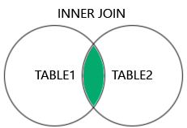
SELECT ProductID, ProductName, CategoryName
FROM Products
INNER JOIN Categories ON Products.CategoryID = Categories.CategoryID;
- LEFT (OUTER) JOIN: Returns all records from the left table, and the matched records from the right table.
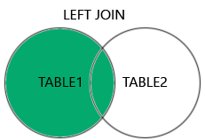
SELECT Customers.CustomerName, Orders.OrderID
FROM Customers
LEFT JOIN Orders ON Customers.CustomerID = Orders.CustomerID
ORDER BY Customers.CustomerName;
- RIGHT (OUTER) JOIN: Returns all records from the right table, and the matched records from the left table.
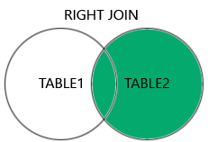
SELECT Orders.OrderID, Employees.LastName, Employees.FirstName
FROM Orders
RIGHT JOIN Employees ON Orders.EmployeeID = Employees.EmployeeID
ORDER BY Orders.OrderID;
- FULL (OUTER) JOIN: Returns all records when there is a match in either left or right table.
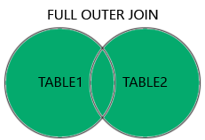
SELECT Customers.CustomerName, Orders.OrderID
FROM Customers
FULL OUTER JOIN Orders ON Customers.CustomerID=Orders.CustomerID
ORDER BY Customers.CustomerName;

Self Join
A self join is a regular join, but the table is joined with itself.
SELECT A.CustomerName AS CustomerName1, B.CustomerName AS CustomerName2, A.City
FROM Customers A, Customers B
WHERE A.CustomerID <> B.CustomerID
AND A.City = B.City
ORDER BY A.City;

3.indexing
Indexing is a very useful technique that helps in optimizing the search time in database queries. The main purpose of indexing is to provide better performance for data retrieval.

4.Microservices gives any scenario and asks a query

1.explain microservices architecture
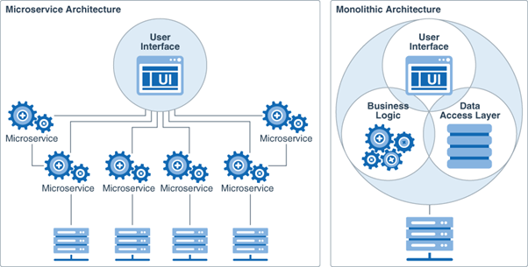
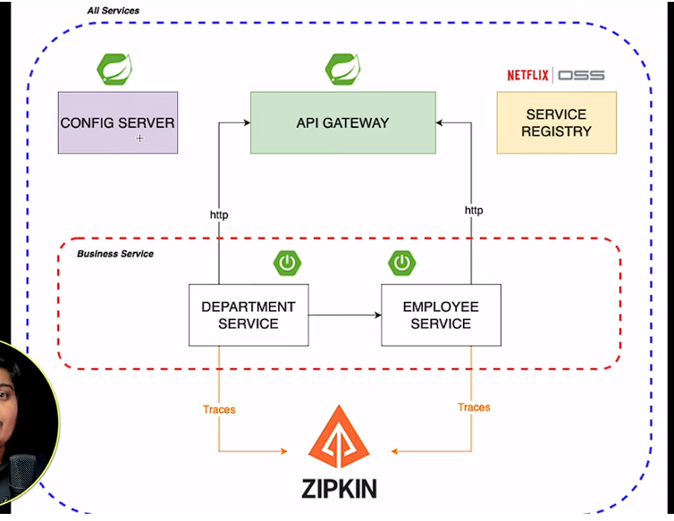

2.how to communicate two microservices
- HTTP/RESTful APIs: This is one of the most common approaches for communication between microservices. Each microservice exposes a set of HTTP endpoints (APIs) that other services can interact with using HTTP requests. RESTful APIs are typically lightweight, stateless, and easy to consume, making them suitable for synchronous communication between services.
- Messaging Queues: Messaging queues, such as RabbitMQ, Apache Kafka, or Amazon SQS, enable asynchronous communication between microservices. A microservice can publish messages to a queue, and other services can consume those messages asynchronously. Messaging queues are useful for decoupling services, improving scalability, and handling high volumes of messages.

REST API calls are common methods of microservices to communicate. REST API calls enable microservices to share data and functionality, which allows microservices to work together seamlessly.
- Messaging: Messaging systems like RabbitMQ, Apache Kafka, or ActiveMQ can be used for asynchronous communication between microservices.

3.about zull server
Zuul Server is an API Gateway application. It handles all the requests and performs the dynamic routing of microservice applications. It is also known as Edge Server. Zuul is built to enable dynamic routing, monitoring, resiliency, and security.

4.about config server
It allows you to store configuration data in a central location like GIT and make it available to all your microservices.

5.eureka server
Eureka Server is a centralized registry that maintains a list of all the registered services and their instances. Eureka Client is a library that interacts with the Eureka Server to register, deregister, and discover other services.

6.load balancing
Load balancing for microservices aims to distribute incoming network traffic across multiple instances of a service to ensure no single instance is overwhelmed with too much traffic. This results in: Optimal Resource Utilization: Traffic distribution ensures that all service instances are used effectively.

7.if one microservice is interacting another microservice..what if another microservice is down..how to handle that?
When any one of the microservice is down, Interaction between services becomes very critical as isolation of failure, resilience and fault tolerance are some of key characteristics for any microservice based architecture.
in case of Implementing a proper fallback mechanism makes more sense and you can implement required logic you wanna write based on use case and dependencies between M1, M2 and M3. you can also raise events in your fallback if needed.

Load Balancing: Use a load balancer in front of your microservices to distribute incoming requests across multiple instances of the same microservice. If one instance fails, the load balancer can automatically redirect the traffic to other healthy instances.

1.About yourself?
2.Difference between Spring and Spring Boot
S.No. | Spring | Spring Boot
1. | Spring is an open-source lightweight framework widely used to develop enterprise applications. | Spring Boot is built on top of the conventional spring framework, widely used to develop REST APIs.
2. | The most important feature of the Spring Framework is dependency injection. | The most important feature of the Spring Boot is Autoconfiguration.
3. | It helps to create a loosely coupled application. | It helps to create a stand-alone application.
4. | To run the Spring application, we need to set the server explicitly. | Spring Boot provides embedded servers such as Tomcat and Jetty etc.
5. | To run the Spring application, a deployment descriptor is required. | There is no requirement for a deployment descriptor.
6. | To create a Spring application, the developers write lots of code. | It reduces the lines of code.
7. | It doesn’t provide support for the in-memory database. | It provides support for the in-memory database such as H2.

3.How to disable the embedded server in spring boot?
To exclude tomcat from spring boot, just need to add an additional block to the Spring Boot Starter dependency. In the dependency section, We can add
<exclusions> tags
02  03  04  05  06  07  08  09  10 | <dependency>  <groupId>org.springframework.boot</groupId>  <artifactId>spring-boot-starter-web</artifactId>  <exclusions>  <exclusion>  <groupId>org.springframework.boot</groupId>  <artifactId>spring-boot-starter-tomcat</artifactId>  </exclusion>  </exclusions>

Exclude Tomcat and All Servers – Annotation
@SpringBootApplication(exclude = {EmbeddedServletContainerAutoConfiguration.class, WebMvcAutoConfiguration.class})

4.How to run the Spring Application

Creating a Spring Boot Application
Step 1: Open the Spring Initializr https://start.spring.io/.
Step 2: Select the Spring Boot version 2.2.2.BUILD-SNAPSHOT.
Step 3: Provide the Group name. We have provided the Group name com.javatpoint.
Step 4: Provide the Artifact. We have provided the Artifact spring-boot-application-run.
Step 5: Add the Spring Web dependency.
Step 6: Click on the Generate button. When we click on the Generate button, it wraps all the specifications related to application into a Jar file and downloads it to the local system.
Step 7: Extract the jar file.
Step 8: Copy the folder and paste it in the STS workspace.
Step 9: Import the project.
The main() method uses Spring Boot's SpringApplication.run() method to launch an application

5.Features of Java 8
- Lambda expression
- Functional Interface
- Predicates
- Function
- Default methods in interface.
- Date Time API
- Optional class
- Stream API

6.Is Functional interface is abstract class in java 8?
Yes, Functional Interface is an abstract class. A class that contains one or more abstract methos is considered as abstract class. Since, Functional interface has at least one abstract method in it. So Functional interface is an Abstract class.
A functional interface in Java is an interface that contains only a single abstract (unimplemented) method. A functional interface can contain default and static methods which do have an implementation, in addition to the single unimplemented method.
The major benefit of java 8 functional interfaces is that we can use lambda expressions to instantiate them and avoid using bulky anonymous class implementation. Java 8 Collections API has been rewritten and new Stream API is introduced that uses a lot of functional interfaces.

7.Difference between Java 7 interface and Java 8 Functional interface
The java 7 interface has only abstract methods which needs to be inherited in class by implementing it but in Java 8 Functional Interface we have an interface with one or more abstract methods also we may have default and static methods with an implementation in interface which allows to achieve backward compatibility.
where an interface has one or multiple implementations, if one or more methods are added to the interface, all the implementations will be forced to implement them too

8.Is default methods contains is concrete method?
An abstract class can have both abstract and concrete methods (concrete methods are methods with complete implementation). Before java 1.8, interface can have only abstract methods, from java 1.8 interfaces can also have both concrete and abstract methods. (concrete methods – static and normal implementation methods and abstract methods)

Java 8:
1.What is Lambda Expression?
A lambda expression is a short block of code which takes in parameters and returns a value. Lambda expressions are similar to methods, but they do not need a name and they can be implemented right in the body of a method.
A Java lambda expression is thus a function which can be created without belonging to any class. ... Java lambda expressions are commonly used to implement simple event listeners / callbacks, or in functional programming with the Java Streams API.

2.What is Functional interface?
A functional interface in Java is an interface that contains only a single abstract (unimplemented) method. A functional interface can contain default and static methods which do have an implementation, in addition to the single unimplemented method.
The major benefit of java 8 functional interfaces is that we can use lambda expressions to instantiate them and avoid using bulky anonymous class implementation. Java 8 Collections API has been rewritten and new Stream API is introduced that uses a lot of functional interfaces.

3.What is default method?
From java 1.8, we can be able to add default methods inside the Interface Which help us to achieve backward compatibility. Java provides a facility to create default methods inside the interface. Methods which are defined inside the interface and tagged with default are known as default methods. These methods are non-abstract methods.

4.Difference between Collections and Stream?
A stream is a sequence of objects that supports various methods which can be pipelined to produce the desired result. The Stream API is used to process collections of objects.
STREAMS | COLLECTIONS
It doesn’t store data, it operates on the source data structure i.e. collection. | It stores/holds all the data that the data structure currently has in a particular data structure like Set, List or Map,
They use functional interfaces like lambda which makes it a good fit for programming language. | Don’t use functional interfaces.
Java Streams are consumable i.e; to traverse the stream, it needs to be created every time. | Non-consumable i.e; can be traversable multiple times without creating it again

5.Difference between filter() and map();
'Map' is used to apply a function on every item in an array and returns the new array. 'Filter' is used to create a new array from an existing one, containing only those items that satisfy a condition specified in a function.

6.Write a code using java 8 to sort the element of Array List in Descending order?
class Array{
public static void main(String[] args) {
ArrayList<Integer> list = new ArrayList();
list.add(55);
list.add(34);
list.add(23);
list.add(65);
list.add(35);
list.add(86);
list.add(432);
list.add(24);
List sortedList = list.stream().sorted().collect(Collectors.toList());
System.out.println("sorted list in ASC"+ sortedList);
List DescList = list.stream().sorted(Comparator.reverseOrder()).collect(Collectors.toList());
System.out.println("sorted List in DESC" + DescList);
}
}

7.Write a code in Java 8 for creating a thread and run()?
class MultiThreading implements Runnable{
public void run(){
System.out.println("thread is running in runnable interface");
}
public static void main(String[] args) {
MultiThreading thread = new MultiThreading(); //object
Thread t1 = new Thread(thread);
t1.start();
}
}
class Java8Thread{
public static void main(String[] args) {
Runnable myThread = () -> System.out.println("MyThread is running using java 8 lambda expression");
Thread t1 = new Thread(myThread);
Thread t2 = new Thread(myThread);
t1.start();
t2.start();
}
}

8.What is Date and Time API?
The Date and Time API, introduced in Java 8, is a modern and comprehensive API for handling dates, times, durations, and time zones in Java applications. Prior to Java 8, Java's built-in date and time handling classes, such as java.util.Date and java.util.Calendar, were widely considered to be problematic and error-prone due to their design flaws and lack of features.
Not thread safe : Unlike old java.util.Date which is not thread safe the new date-time API is immutable and doesn’t have setter methods.
Less operations : In old API there are only few date operations but the new API provides us with many date operations.

9.What is Predicate?
predicate means a statement that determines whether a value could be true or false. In programming predicates mean functions with one argument that returns a Boolean value. Functional Interface Predicate was realized in Java 8. “Functional” means that it contains only one abstract method.

10.What is :: operator in java 8?
The double colon (::) operator, also known as method reference operator in Java, is used to call a method by referring to it with the help of its class directly. They behave exactly as the lambda expressions(It’s shortcut for an lambda expression). The only difference it has from lambda expressions is that this uses direct reference to the method by name instead of providing a delegate to the method.
Syntax:
<Class name>::<method name>

11.What is Optional class in java 8?
Java introduced a new class Optional in jdk8. It is a public final class and used to deal with NullPointerException in Java application. You must import java.util package to use this class. It is used to represent a value that may or may not be present. In other words, an Optional object can either contain a non-null value (in which case it is considered present) or it can contain no value at all (in which case it is considered empty).
Optional.empty() //returns an optional empty if no value is present
Optional.of() //returns a value if the value is present otherwise return optional empty
Optional.OfNullable() // returns a value if it’s present otherwise handle the nullpointer exception.

12.What is Split Iterator in java 8?
The Spliterator interface in Java 8 is a new addition to the Java Collections framework that provides a way to split a source of elements into multiple parts for parallel processing. It is designed to work seamlessly with the Stream API introduced in Java 8 and is used internally by various stream operations to efficiently process large datasets in parallel.

13.For a employee class sort in desending order?
emp.stream().sorted(comparator.reverseOrder).forEach(System.out::println);

Product descOrder = emp.stream().max(comparator.comparing(Employee::getSalary))
.orelse(null);

14.What is min,max,shutdown?

Core Java:
1.What are the OOPs feature explain them?
  - Encapsulation
  - Polymorphism
  - Abstraction
  - Inheritance
2.What is Overloading and Overriding?
Overloading: Complie time polymorphism. Overloading means having a same method name, same class name but with different no.of arguments while return type may or may not be different which allow us to reuse the same method name.
Overriding: Run-time Polymorphism. Overriding means having the same method name, same no.of arguments but occurs in different class that has inheritance relationship.

3.1. What kind of Collections you have used in your project?
Ans: ArrayList Class, Hashset Class, HashMap Class,LinkedList Class,TreeMap Class

1b) Why you used these collections?
Fetch data from database and store each record into suitable collection class.
Hold the data and transfer the data from UI to database and vice versa.
Removing of the duplicate data (String or Objects) by using sets.
Search the data in the collections class
Storing the objects in key value pair.
Can store values beyond the limit size as it won’t throw NullPointer exception because Array List is a dynamic array where it’s resizable

4.) Can you make static reference to non-static fields(variables) in Java?
No, static reference to non-static fields(variables) in Java. Because static variables will share the share memory for the entire class and it will be invoked by using their class name but non-static variables needs an object for it to call.

5.) Please name the OOPS principles
Abstraction, Encapsulation, Inheritance and Polymorphism

6) Can you give real time examples for abstraction and encapsulation?
Refrigerator, Cell Phone is a real time example for abstraction and encapsulation

7) What is main memory in Java?
Ans The JVM divides its memory into two main categories: heap memory and non-heap memory. Heap memory is the part with which people are typically the most familiar. It's where objects that are created by the application are stored. As JVM works on variables are stored in heap memory.

8.) What is custom exception in Java?
In Java, we can create our own exceptions that are derived classes of the Exception class. Creating our own Exception is known as custom exception or User-defined custom exception.

9). Have you written Code using Java 8?
Yes. Using lambda expression and functional Interfaces

10.Can static method can be override?
No, we can’t override static methods in java, because of overriding may completely depends on the objects that we have created but on the other hand static method can depend/calling by using their class name only. So static methods couldn’t be overridden.
No, we cannot override static methods because method overriding is based on dynamic binding at runtime and the static methods are bonded using static binding at compile time. So, we cannot override static methods.

11.what is static in java?
When you declare a variable or a method as static, it belongs to the class, rather than a specific instance. This means that only one instance of a static member exists, even if you create multiple objects of the class, or if you don't create any. It will be shared by all objects.

12.What is this, Super and why they are used?
this keyword refers to the current class/current method/current constructor Object.
Super keyword allows access to the members of the parent class. It is used to call superclass methods, and to access the superclass constructor. The most common use of the super keyword is to eliminate the confusion between super classes and subclasses that have methods with the same name.

13.Real time example of OOPs feature
Encapsulation (Medical capsule, class and objects are tightly bounded with private specifier)
Inheritance (Relationship of our anchestors)
Abstraction (Mobile Phone)
Polymorphism (A person can be a worker, husband, brother, parent)

14.What are the java feature list down all?
- Simple and Easy to Learn.
- Object-Oriented Programming.
- Platform Independence.
- Automatic Memory Management.
- Security.
- Multithreading.
- High Performance.

15.what is static and dynamic loading?
In static loading, Initially, the complete program is loaded into the main memory before execution. In the case of static loading, the entire program is compiled and linked, leaving no program or external module dependencies at compile time.
- In static loading, the entire program, including all the libraries or modules it depends on, is loaded into memory before execution starts.
- The linking between the program and its dependencies (libraries or modules) is done at compile time.
- Once loaded into memory, the program runs independently of the external environment and does not require any additional loading during execution.

Dynamic loading refers to the process of loading a program into the main memory on demand. Dynamic loading, the compiler, the program, and for any module that needs to be included dynamically,- that provided only as a reference to them, and the rest of the work will be done at runtime. And the complete program and all process data must be in physical memory for the process to run.
- In dynamic loading, only the essential parts of a program are loaded into memory at startup, and additional libraries or modules are loaded into memory only when they are explicitly required during runtime.
- The linking between the program and its dependencies is deferred until runtime, allowing for greater flexibility and modularity.

16.How many ways are there to create the object?
- Using new keyword // GFG obj = new GFG();
- Using new instance //GFG obj = (GFG)cls.newInstance();
- Using clone() method // class GFG implements Cloneable{}
- Using deserialization // class GFG implements Serializable{}
- Using newInstance() method of Constructor class // class GFG { GFG(){} }

17.What is marker interface?
A marker interface in Java is primarily used to mark or flag classes with specific characteristics or behaviors without adding any methods or fields. It provides a way to convey information to the compiler or runtime about the intended behavior of a class.

18.What is SCP? (String Constant pool)
The Java string constant pool is an area in heap memory where Java stores literal string values. The heap is an area of memory used for run-time operations. When a new variable is created and given a value, Java checks to see if that exact value exists in the pool.

19.Why String is immutable?
The String is immutable, so its value cannot be changed. If the String doesn't remain immutable, any hacker can cause a security issue in the application by changing the reference value. The String is safe for multithreading because of its immutableness.
String is immutable means that you cannot change the object itself, but you can change the reference to the object. When you execute a = "ty" , you are actually changing the reference of a to a new object created by the String literal "ty" .

20.Contract between .equals() and HashCode?
The basic rule of the contract states that if two objects are equal to each other based on equals() method, then the hash code must be the same, but if the hash code is the same, then equals() can return false.
The equals() method of Object class checks the equality of the objects and accordingly it returns true or false. The default implementation, as provided by Object class, checks the equality of the objects on the basis if both references refer to the same object.
- Consistency: The contract mandates that if two objects are equal according to the .equals() method, then their hash codes produced by the hashCode() method must also be equal. In other words, if a.equals(b) returns true, then a.hashCode() should return the same value as b.hashCode().

General contract associated with equals() method
For any non-null reference variables a, b and c
- a.equals(a) should always return true.
- a.equals(b) should return true if and only if b.equals(a) returns true.
- If a.equals(b) returns true and b.equals(c) returns true then a.equals(c) should return true.
- Multiple calling of a.equals(b) should consistently return true or consistently return false If the value of the object is not modified for either object.
- a.equals(null) should return false.

This method returns an integer value, which is referred to as the hash code value of an object. Every Object, at the time of creation assigned with a unique 32-bit, signed int value. This value is the hash code value of that object.

General contract associated with hashCode() method
- The hashCode() method should return the same integer value for the same object for each calling of this method unless the value stored in the object is modified.
- If two objects are equal(according to equals() method) then the hashCode() method should return the same integer value for both the objects.

21.why to Override the hashCode?
We should remember to:
- Always override hashCode() if we override equals()
- You must override hashCode() in every class that overrides equals(). Failure to do so will result in a violation of the general contract for Object.hashCode(),
- If two objects are equal according to the equals(Object) method, then calling the hashCode method on each of the two objects must produce the same integer result.
- "If two objects are equal using Object class equals method, then the hashcode method should give the same value for these two objects." So, if in our class we override equals() we should override hashcode() method also to follow this rule.

22.What is Cloning and explain with example?
The object cloning is a way to create exact copy of an object. The clone() method of Object class is used to clone an object. The java.lang.Cloneable interface must be implemented by the class whose object clone we want to create.

- class GFG implements Cloneable {
- public Object clone()throws CloneNotSupportedException{
- return super.clone();
- }
- }

23.Which cloning is prefer?
When it comes to cloning objects in Java, there are two main approaches: shallow cloning and deep cloning. Each approach has its advantages and considerations
Shallow Cloning:
  - Shallow cloning creates a new object but does not create new copies of the objects referenced by the original object. Instead, it copies the references to these objects. As a result, both the original and cloned objects share references to the same objects (referred to as shallow copies).
  - Shallow cloning is generally faster and simpler to implement because it only involves copying the object's fields without recursively copying the referenced objects.
Deep Cloning:
- Deep cloning creates a new object and recursively creates new copies of all the objects referenced by the original object, ensuring that the cloned object is fully independent of the original (referred to as deep copies).
- Deep cloning ensures complete isolation between the original and cloned objects, making it safer when dealing with mutable objects. Changes made to objects referenced by one object do not affect the other.

24.List down all the methods of Object class?
Object class has below methods
- toString() Method.
- hashCode() Method.
- equals(Object obj) Method.
- getClass() method.
- finalize() method.
- clone() method.
- wait(), notify() notifyAll() Methods.

25.Difference between StringBuffer and StringBuilder?
The String class is an immutable class whereas StringBuffer and StringBuilder classes are mutable. ... StringBuffer is synchronized i.e. thread safe. It means two threads can't call the methods of StringBuffer simultaneously. StringBuilder is non-synchronized i.e. not thread safe.
26.What is Array and Collection?
Array is a group of homogeneous data-type objects that are fixed in size, and this is strongly typed. A collection is a group of homogeneous and heterogeneous data-type objects that is not fixed in size and thus is not strongly typed. But we use Generic to make Collection a strong Type.
Arrays are fixed in size that is once we create an array we can not increased or decreased based on our requirement. Collection are growable in nature that is based on our requirement. We can increase or decrease of size

26.Differnce between Collection and Collections?
Collection is the interface where you group objects into a single unit. Collections is a utility class that has some set of operations you perform on Collection. Collection does not have all static methods in it, but Collections consist of methods that are all static. Collection class implements Iterable Interface whereas Collections class extends Object class.
Eg: Collections.sort(), Collections.addAll();

26.Difference between ArrayList and Vector?
ArrayList | Vector
1) ArrayList is not synchronized. | Vector is synchronized.
2) ArrayList increments 50% of current array size if the number of elements exceeds from its capacity. | Vector increments 100% means doubles the array size if the total number of elements exceeds than its capacity.
3) ArrayList is not a legacy class. It is introduced in JDK 1.2. | Vector is a legacy class.
4) ArrayList is fast because it is non-synchronized. | Vector is slow because it is synchronized, i.e., in a multithreading environment, it holds the other threads in runnable or non-runnable state until current thread releases the lock of the object.
5) ArrayList uses the Iterator interface to traverse the elements. | A Vector can use the Iterator interface or Enumeration interface to traverse the elements.

27.Difference between ArrayList and LinkedList?
ArrayList | LinkedList
1) ArrayList internally uses a dynamic array to store the elements. //dynamic maarum | LinkedList internally uses a doubly linked list to store the elements.
2) Manipulation with ArrayList is slow because it internally uses an array. If any element is removed from the array, all the other elements are shifted in memory. | Manipulation with LinkedList is faster than ArrayList because it uses a doubly linked list, so no bit shifting is required in memory.
3) An ArrayList class can act as a list only because it implements List only. | LinkedList class can act as a list and queue both because it implements List and Deque interfaces.
4) ArrayList is better for storing and accessing data. | LinkedList is better for manipulating data.
5) Generally, when an ArrayList is initialized, a default capacity of 10 is assigned to the ArrayList. | There is no case of default capacity in a LinkedList. In LinkedList, an empty list is created when a LinkedList is initialized.
6) To be precise, an ArrayList is a resizable array. | LinkedList implements the doubly linked list of the list interface.

28.What is set?
Set in Java is an interface declared in java. util package. It extends the collection interface that allows creating an unordered collection or list, where duplicate values are not allowed.
Types of Set:
  - HashSet // unordered elements and no duplicates
  - Linked HashSet //ordered elements and no duplicates
  - TreeSet //objects in the class are stored in ASC order. Uses tree for storage

29.What is HasMap and how to make hashmap Syncronized?
HashMap is a non-synchronized collection class. If we want to perform thread-safe operations on it, then we must have to synchronize it explicitly. In order to synchronize it explicitly the synchronizedMap() method of java. Synchronized hashmap is thread-safe and is applied on a whole object.

Map<Integer, String> hMap = new HashMap();
hMap.put(1, “ABC”);
hMap.put(2, “DEF”);
hMap.put(3, “EFG”);
Map<Integer, String> synchrMap = Collections.synchronizedMap(hmap); System.out.println("Synchronized Map : ");

// Synchronized block
synchronized (synchrMap)
{

// Iterate synchronized map
for (Map.Entry<Integer, String> entry :
synchrMap.entrySet()) {

// Print key : value
System.out.println(entry.getKey() + " : "
+ entry.getValue());
}

30.Differnce between HashMap and Concurrent Collection?
HashMap isn't thread-safe at all. Thus, it is non-synchronized in nature. The ConcurrentHashMap, on the other hand, is thread-safe. Due to non-synchronization, the performance of HashMap is relatively higher, and various threads are capable of performing simultaneously.

31.Difference between HashMap and HashTable?
HashMap | Hashtable
1) HashMap is non synchronized. It is not-thread safe and can't be shared between many threads without proper synchronization code. | Hashtable is synchronized. It is thread-safe and can be shared with many threads.
2) HashMap allows one null key and multiple null values. | Hashtable doesn't allow any null key or value.
3) HashMap is a new class introduced in JDK 1.2. | Hashtable is a legacy class.
4) HashMap is fast. | Hashtable is slow.

32.What is Fail-safe and Fail-fast?
Fail-fast and Fail-safe are the iterators or collections in Java.
Fail-fast: When we use the Fail-fast iterator, it immediately throws ConcurrentModificationException when an element is added or removed from the collection while the thread is iterating over the collection. Examples: Iterator in HashMap, Iterator on ArrayList, etc.
Fail-Safe: It is better to call it a Non-Fail-fast Iterator. The Fail-safe iterator doesn't throw the ConcurrentModificationException, and it tries to avoid raising the exception. The Fail-safe iterator creates a copy of the original collection or object array and iterates over that copied collection. Any structural modification made in the iterator affects the copied collection, not the original collection. Therefore, the original collection remains structurally unchanged.

33.What is multithreading?
Multithreading in Java is a process of executing multiple threads simultaneously.
A thread is a lightweight sub-process, the smallest unit of processing. Multiprocessing and multithreading, both are used to achieve multitasking.
However, we use multithreading than multiprocessing because threads use a shared memory area.

34.What is Thread?
A thread, in the context of Java, is the path followed when executing a program. ... In Java, creating a thread is accomplished by implementing an interface and extending a class. Every Java thread is created and controlled by the java. lang. Thread class.
35.How to create the thread?
There are two ways to create a thread:
- By extending Thread class
- By implementing Runnable interface.

36.What is Synchronized block?
Synchronized block can be used to perform synchronization on any specific resource of the method.
Suppose we have 50 lines of code in our method, but we want to synchronize only 5 lines, in such cases, we can use synchronized block.
If we put all the codes of the method in the synchronized block, it will work same as the synchronized method.

Points to Remember
- Synchronized block is used to lock an object for any shared resource.
- Scope of synchronized block is smaller than the method.
- Java synchronized block is more efficient than Java synchronized method.

Syntax
- synchronized (object reference expression) {
- //code block
- }

37.What is Thread Pool?
Java Thread pool represents a group of worker threads that are waiting for the job and reused many times. In the case of a thread pool, a group of fixed-size threads is created. A thread from the thread pool is pulled out and assigned a job by the service provider. After completion of the job, the thread is contained in the thread pool again.
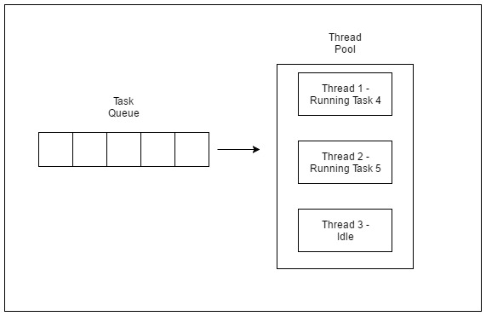
38.Difference between Yield ,join and sleep?
property | yield() | join() | sleep()
purpose | If a thread wants to pass its execution to give chance to remaining threads of same priority then we should go for yield() | If a thread wants to wait until completing of some other thread then we should go for join() | If a thread does not want to perform any operation for a particular amount of time, then it goes for sleep()
Is it overloaded? | NO | YES | YES
Is it final? | NO | YES | NO
Is it throws? | NO | YES | YES
Is it native? | YES | NO | sleep(long ms)->native & sleep (long ms, int ns)-> non native
Is it static? | YES | NO | YES

39.Disadvntages of Multithreading?
- Increased complexity: Multithreaded programs can be more complex and difficult to understand, design, and maintain. This is especially true when dealing with shared resources, synchronization, and deadlocks.
- Higher memory consumption: Each thread requires its own stack and program counter, which can lead to increased memory consumption and slow down the performance of the program.
- Difficulty in debugging: Debugging a multithreaded program can be challenging since it can be difficult to reproduce the issue and identify which thread caused the problem.
- Increased chance of deadlocks: Deadlocks can occur when two or more threads are blocked waiting for resources held by each other, causing the program to freeze or crash.
- Difficulty in prioritizing threads: When there are multiple threads running simultaneously, it can be difficult to prioritize which threads should have access to system resources such as CPU and memory.
40.What is Volatile keyword?
Using volatile is yet another way (like synchronized ) of making class thread-safe. Thread-safe means that a method or class instance can be used by multiple threads at the same time without any problem.
Suppose that two threads are working on SharedObj. If two threads run on different processors each thread may have its own local copy of sharedVariable. If one thread modifies its value, the change might not reflect in the original one in the main memory instantly. This depends on the write policy of cache. Now the other thread is not aware of the modified value which leads to data inconsistency.
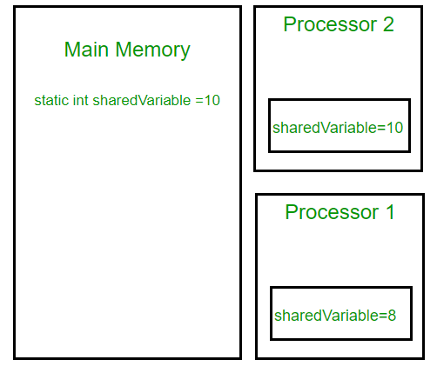
41.What is transient keyword?
transient is a variables modifier used in serialization. At the time of serialization, if we don’t want to save value of a particular variable in a file, then we use transient keyword. When JVM comes across transient keyword, it ignores original value of the variable and save default value of that variable data type.

42.Difference between start() and run()?

start() | run()
Creates a new thread and the run() method is executed on the newly created thread. | No new thread is created and the run() method is executed on the calling thread itself.
Can’t be invoked more than one time otherwise throws java.lang.IllegalStateException | Multiple invocation is possible
Defined in java.lang.Thread class. | Defined in java.lang.Runnable interface and must be overridden in the implementing class.

43.What is Callable?
Callable interface in Java is used to make a class instance run as a thread by implementing it. The Callable interface is provided by the java. util. concurrent package. The Callable interface can return any object as a result and can throw an exception.

- public Object call() throws Exception
{}

Callable | Runnable
It is mandatory to define call() method if we are dealing with the Callable interface. | It is mandatory to define the run() method if we are dealing with the Runnable interface.
The return type of the call() method of the interface is an Object. Hence, the call() method returns an Object. | The return type of the run() method of the interface is void. Hence, the run() method returns void.
The call() method can throw an exception. | The run() method cannot throw an exception.
A thread cannot be created using the Callable interface. | A thread can be created using the Runnable interface.

44.If there is multiple processes are there how each thread start its execution?
The client class invokes the start() method of the Runnable object. The result is two thread running concurrently – the current thread continue after invoking the start() , and a new thread that executes run() method of the Runnable object.

45.How to handle the exception in java?
Java provides two different options to handle an exception. You can either use the try-catch-finally approach to handle all kinds of exceptions. Or you can use the try-with-resource approach which allows an easier cleanup process for resources.
46.What is Difference between checked and unchecked exception?

1) Checked Exception
The classes that directly inherit the Throwable class except RuntimeException and Error are known as checked exceptions. For example, IOException, SQLException, etc. Checked exceptions are checked at compile-time.

2) Unchecked Exception
The classes that inherit the RuntimeException are known as unchecked exceptions. For example, ArithmeticException, NullPointerException, ArrayIndexOutOfBoundsException, etc. Unchecked exceptions are not checked at compile-time, but they are checked at runtime.

47.Difference between throw and throws?
Sr. no. | Throw | Throws
1. | Java throw keyword is used throw an exception explicitly in the code, inside the function or the block of code. | Java throws keyword is used in the method signature to declare an exception which might be thrown by the function while the execution of the code.
2. | Using throw keyword, we can declare both checked and unchecked exceptions. | However, the throws keyword can be used to propagate checked exceptions only.
3. | The throw keyword is followed by an instance of Exception to be thrown. | The throws keyword is followed by class names of Exceptions to be thrown.
4. | throw is used within the method. | throws is used with the method signature.
5. | We are allowed to throw only one exception at a time i.e. we cannot throw multiple exceptions. | We can declare multiple exceptions using throws keyword that can be thrown by the method. For example, main() throws IOException, SQLException.

48.At what scenario finally will not be executed?
A finally block always executes, regardless of whether an exception is thrown or not.
There are two conditions in which statements in the finally block will not be executed in Java. They are as follows:
1. When the return statement is defined in the finally block, the control of execution is transferred to calling routine, and statements after the return statement in finally block are not executed.
2. When an exception occurs in the code written in the finally block. In this case, finally block does not complete normally.

49.what is Serialization?
Serialization is the process of converting a data object into a series of bytes that saves the state of the object in an easily transmittable form.
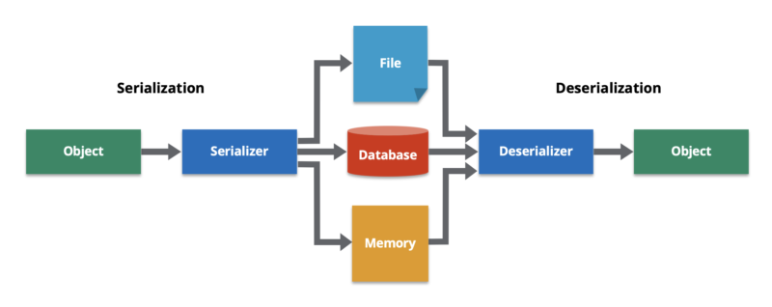
50.What is Externalization?
Externalization in Java is used to customize the serialization mechanism. Java serialization is not much efficient. When we have bloated objects that hold several attributes and properties, it is not good to serialize them. Here, the externalization will be more efficient.

Spring Boot:
1.What is Spring Boot and Explain each features?
- Spring Boot is built on top of the conventional spring framework, widely used to develop REST APIs.
- The most important feature of the Spring Boot is Autoconfiguration.
- It helps to create a stand-alone application.
- Spring Boot provides embedded servers such as Tomcat and Jetty etc.

Features of Spring Boot:
  - Opinionated ‘starter' dependencies to simplify the build and application configuration.
  - Embedded server to avoid complexity in application deployment.
  - Metrics, Health check, and externalized configuration
  - Automatic config for Spring functionality – whenever possible
Features of Spring:
  - Predefined template (Eg: JDBC template)
  - Loose coupling (If one module is modified, that it’ll not affect another module)
  - Light weight

2.Difference between Spring and Spring Boot?
S.No. | Spring | Spring Boot
1. | Spring is an open-source lightweight framework widely used to develop enterprise applications. | Spring Boot is built on top of the conventional spring framework, widely used to develop REST APIs.
2. | The most important feature of the Spring Framework is dependency injection. | The most important feature of the Spring Boot is Autoconfiguration.
3. | It helps to create a loosely coupled application. | It helps to create a stand-alone application.
4. | To run the Spring application, we need to set the server explicitly. | Spring Boot provides embedded servers such as Tomcat and Jetty etc.
5. | To run the Spring application, a deployment descriptor is required. | There is no requirement for a deployment descriptor.
6. | To create a Spring application, the developers write lots of code. | It reduces the lines of code.
7. | It doesn’t provide support for the in-memory database. | It provides support for the in-memory database such as H2.

3.What are the annotations in Spring Boot?
Spring Boot Annotations - javatpoint

4.How AutoConfiguration works and what annotation requires to work autoconfiguration?
The @EnableAutoConfiguration annotation enables Spring Boot to auto-configure the application context.
Auto-configuration automatically configures beans and settings based on the presence of dependencies in the classpath, reducing the need for manual configuration. This simplifies the configuration process and reduces boilerplate code.

5.How to set the port in Embedded tomcat servlet?
- Change the Port Using Configuration Files. //server.port=8085
- Command Line Argument.
- Spring Boot 2: Change Port Using the ConfigurableServletWebServerFactory Class.
- Spring Boot 1: Change Port Using the ConfigurableEmbeddedServletContainer.
- Use a Random HTTP Port.
If you wish Spring Boot to pick a random HTTP port, which is useful if you want to avoid clashes, you can do this by setting server.port=0. By setting server.port to 0, Spring Boot will scan your machine and use an available port.

6.Way to disable the Embedded tomcat servlet?
If we want to exclude tomcat from spring boot, we don't need to do much, we just need to add one additional block(<exclusions>) to the Spring Boot dependency. <exclusions> tag is used to make us sure that given server/artifactId is being removed at the time of build.

7.What is @SpringBootApplication will do and where it is used?
This annotation simplifies the setup of a Spring Boot application. By placing it on your main class, you declare it as the starting point of your application. Spring Boot then handles much of the configuration and bootstrapping for you.
@SpringBootApplication= @ComponentScan + @EnableAutoConfiguration + @Configuration

8.tell me SpringApplication.run() will do?
In a Spring Boot application, the SpringApplication.run() method is typically used to bootstrap and launch a Spring application. This method starts the Spring application context, which initializes and configures all the beans and components defined in your application, and then starts the embedded web server if your application is a web application.
You can consider the Application Context as the main container for Spring. In Spring when you define classes, those classes(Also called as beans) are managed by the Application Context. And the run() method creates this Application Context.

9.How to handle exception in SpringBoot?
One of the fundamental ways to handle exceptions globally in a Spring Boot application is by using the @ControllerAdvice annotation. This annotation allows you to define global exception handlers that will be applied across all controllers. //class-level

Using @ExceptionHandler //method-level
You can add extra (@ExceptionHandler) methods to any controller to specifically handle exceptions thrown by request handling (@RequestMapping) methods in the same controller. Such methods can:
- Handle exceptions without the @ResponseStatus annotation (typically predefined exceptions that you didn't write)
- Redirect the user to a dedicated error view
- Build a totally custom error response

10.How to create the Spring Boot project?

Step 1: Start a new Spring Boot project
Use start.spring.io to create a “web” project. In the “Dependencies” dialog search for and add the “web” dependency as shown in the screenshot. Hit the “Generate” button, download the zip, and unpack it into a folder on your computer.

Spring Data JPA?
1.Tell me end to end working of Spring Data JPA?
- Create Spring Boot Project. ...
- Add related Maven Dependencies in pom.xml(spring-boot-starter-data-jpa, mysql-connector-j)
- Configure MySQL Database in application.properties
- Creating Model Layer. ...
- Create a Repository Layer. And extends JPA repository
- We can write a query method for to find anything in JPA
  - Eg: Product findByName(String name);
  - It’ll search in the database for the value using the given query
- Create a Service Layer. ...
- Create a Controller Layer. ...
- Run Spring Boot Application.

2.How to handle exception in Spring Data JPA?
We can directly throw an error in service class by using throw new UserDataAccessException().

3. Any JPA exceptions?

NonUniqueResultException
The Spring Data JPA framework throws a NonUniqueResultException runtime exception when a query method is expected to return a single result, but more than one result is found. This can occur when a query is executed using one of Spring Data JPA’s query methods, such as findById(), findOne(), or a custom-defined method that does not return a collection.
When the NonUniqueResultException is thrown, it means that the method being used was designed to return a single result, but it found more than one. This can be due to an incorrect query or inconsistent data in the database.

Microservices?
1.Microservices Architecture



2.Difference between Monolithic and Microservices?
A monolithic application is built as a single unified unit while a microservices architecture is a collection of smaller, independently deployable services.
- In a monolithic application, the entire application is developed as a single codebase, and it is deployed as a single unit. Any updates or changes to the application require redeploying the entire monolith. - In microservices architecture, each service is developed and deployed independently

Aspect | Monolithic Architecture | Microservice Architecture
Architecture | Single-tier architecture | Multi-tier architecture
Size | Large, all components tightly coupled | Small, loosely coupled components
Deployment | Deployed as a single unit | Individual services can be deployed independently
Scalability | Horizontal scaling can be challenging | Easier to scale horizontally
Development | Development is simpler initially | Complex due to managing multiple services
Fault Tolerance | Entire application may fail if a part fails | Individual services can fail without affecting others
Maintenance | Easier to maintain due to its simplicity | Requires more effort to manage multiple services
Communication | Communication between components is faster | Communication may be slower due to network calls

3.Tell me end to end working of Microservices with respect to your project?
4.Why Microservices is needed?
A microservices architecture lets teams deploy independent applications without affecting other services in the architecture. This feature, one of the pros of microservices, will enable developers to add new modules without redesigning the system's complete structure.
5.Advantage and Disadvantage of Microservices?

Advantages of Microservices
- Microservices are self-contained, independent deployment module.
- The cost of scaling is comparatively less than the monolithic architecture.
- Microservices are independently manageable services. It can enable more and more services as the need arises. It minimizes the impact on existing service.
- It is possible to change or upgrade each service individually rather than upgrading in the entire application.
- Microservices follows the single responsibility principle.

Disadvantages of Microservices
- Microservices has all the associated complexities of the distributed system.
- There is a higher chance of failure during communication between different services.
- Difficult to manage a large number of services.
- The developer needs to solve the problem, such as network latency and load balancing.
- Complex testing over a distributed environment.

6.How to manage the Transaction in Microservices?
One of the most widely used design patterns for handling distributed transactions in microservices is the saga pattern. The saga pattern is based on the idea of breaking a long-running transaction into a series of local transactions, each executed by a different service, and compensating for any failures along the way.

7.What is Circuit Breaker?
Circuit Breakers in Microservices serve as a protective shield, ensuring that the system remains operational, even when some parts face issues. They function much like electrical circuit breakers, stopping the flow of requests to a service that appears to be failing
Use of the Circuit Breaker pattern can allow a microservice to continue operating when a related service fails, preventing the failure from cascading and giving the failing service time to recover.

8.How to handle exception in Microservices?
@ExceptionHandler(classname.class) this is for specific exception and it’s method level
@ControllerAdvice this is a global level exception handling method and it’s called Global exception handler.

9.Write a scenario where SpringDataJPA, SpringBoot and Spring Rest used in microservice?
10.How to balance load in Microservices if request increased on service?
11.How to manage Configuration in microservices?
12.How to manage cache in microservices?
13.What is API gateway, what security it is using?
14.Difference between Rest and microservice?
15.Difference between SpringBoot and microservice?

Spring Rest:
1.Difference between rest and soap?
2.What are different methods avaliable?

3.What is @GET,@POST and @Patch?
- @GetMapping: It maps the HTTP GET requests on the specific handler method. It is used to create a web service endpoint that fetches It is used instead of using: @RequestMapping(method = RequestMethod.GET)
- @PostMapping: It maps the HTTP POST requests on the specific handler method. It is used to create a web service endpoint that creates It is used instead of using: @RequestMapping(method = RequestMethod.POST)
- @PutMapping: It maps the HTTP PUT requests on the specific handler method. It is used to create a web service endpoint that creates or updates It is used instead of using: @RequestMapping(method = RequestMethod.PUT)
- @DeleteMapping: It maps the HTTP DELETE requests on the specific handler method. It is used to create a web service endpoint that deletes a resource. It is used instead of using: @RequestMapping(method = RequestMethod.DELETE)
- @PatchMapping: It maps the HTTP PATCH requests on the specific handler method. It is used instead of using: @RequestMapping(method = RequestMethod.PATCH). The PATCH HTTP method is used to update the resource partially and the @PatchMapping annotation is for mapping HTTP PATCH requests onto specific handler methods.

4.I want to perform the db operation insert the data into resource class for example employee details. Which Http method will you use?
5.What is WebServices?

SQL:
1.What is view?
In SQL, a view is a virtual table based on the result-set of an SQL statement.
A view is created with the CREATE VIEW statement.

2.What is stored procedure?
A stored procedure is a prepared SQL code that you can save, so the code can be reused over and over again.
CREATE PROCEDURE procedure_name;

3.What is Index?
Indexes are used to retrieve data from the database more quickly than otherwise. The users cannot see the indexes, they are just used to speed up searches/queries.
CREATE INDEX index_name;

4.Inner Join?
The INNER JOIN keyword selects records that have matching values in both tables.
SELECT ProductID, ProductName, CategoryName
FROM Products
INNER JOIN Categories ON Products.CategoryID = Categories.CategoryID;

5.Subquery
6.Aggregate function
An aggregate function is a function that performs a calculation on a set of values, and returns a single value.
The most commonly used SQL aggregate functions are:
- MIN() - returns the smallest value within the selected column
- MAX() - returns the largest value within the selected column
- COUNT() - returns the number of rows in a set
- SUM() - returns the total sum of a numerical column
- AVG() - returns the average value of a numerical column

SQL:
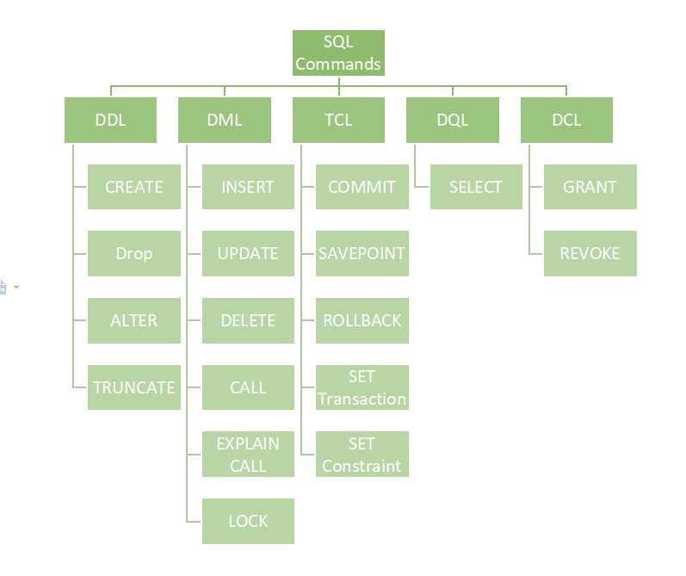
1) DDL (Data Definition Language)
DDL or Data Definition Language actually consists of the SQL commands that can be used to define the database schema.

List of DDL commands:
- CREATE: This command is used to create the database or its objects (like table, index, function, views, store procedure, and triggers).
- DROP: This command is used to delete objects from the database.
- ALTER: This is used to alter the structure of the database.
- TRUNCATE: This is used to remove all records from a table, including all spaces allocated for the records are removed.
- COMMENT: This is used to add comments to the data dictionary.
- RENAME: This is used to rename an object existing in the database.

2) DML (Data Manipulation Language)
The SQL commands that deal with the manipulation of data present in the database belong to DML
List of DML commands:
- INSERT: It is used to insert data into a table.
- UPDATE: It is used to update existing data within a table.
- DELETE: It is used to delete records from a database table.
- LOCK: Table control concurrency.

3) TCL (Transaction Control Language)
Transactions group a set of tasks into a single execution unit. Each transaction begins with a specific task and ends when all the tasks in the group are successfully completed. If any of the tasks fail, the transaction fails. Therefore, a transaction has only two results: success or failure.
BEGIN: Opens a Transaction.
COMMIT: Commits a Transaction.
Syntax:
COMMIT;
ROLLBACK: Rollbacks a transaction in case of any error occurs.

4) Joins
A JOIN clause is used to combine rows from two or more tables, based on a related column between them.
Here are the different types of the JOINs in SQL:
- (INNER) JOIN: Returns records that have matching values in both tables
- LEFT (OUTER) JOIN: Returns all records from the left table, and the matched records from the right table
- RIGHT (OUTER) JOIN: Returns all records from the right table, and the matched records from the left table
- FULL (OUTER) JOIN: Returns all records when there is a match in either left or right table


  - Highest salary query
- Select Max( Salary) from Employee ;

